**Year 10 History Assessment 2: In-Class Source Analysis**

**Source Booklet**

**Source 1**: Unemployment in the USA, 1929-33, created 1999.

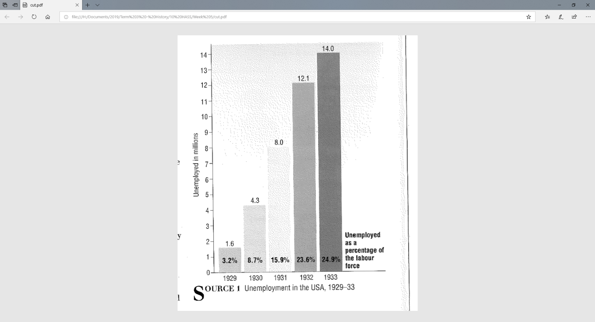

**Source 2:** From a speech by Australian Prime Minister, Robert Menzies, in *The Sydney Morning Herald,* 26th August 1939

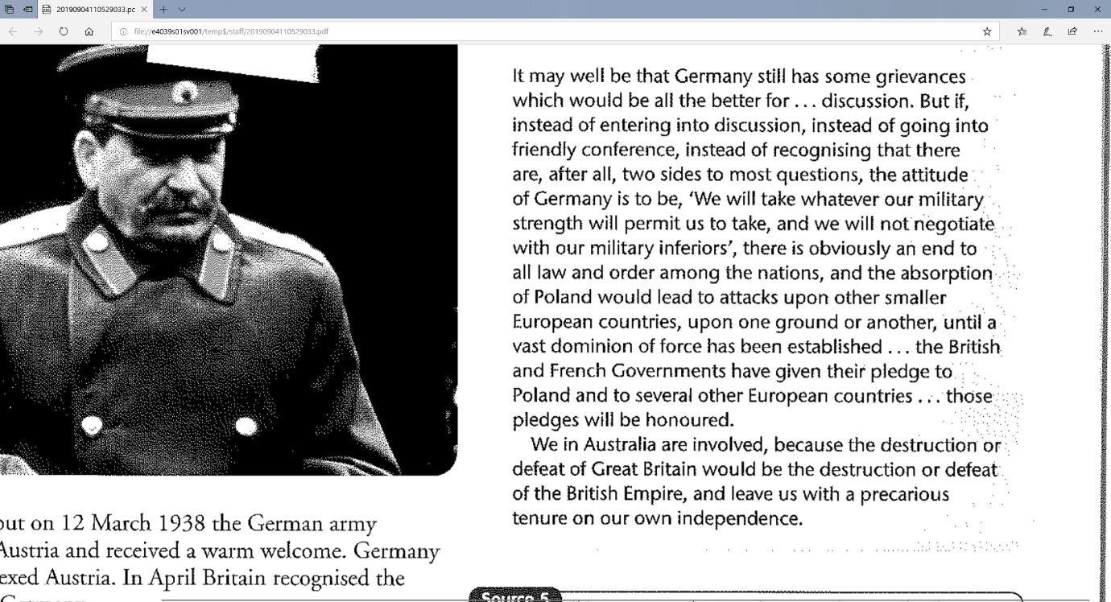

**Source 3:** Australian propaganda poster, 1941, *He’s Coming South*

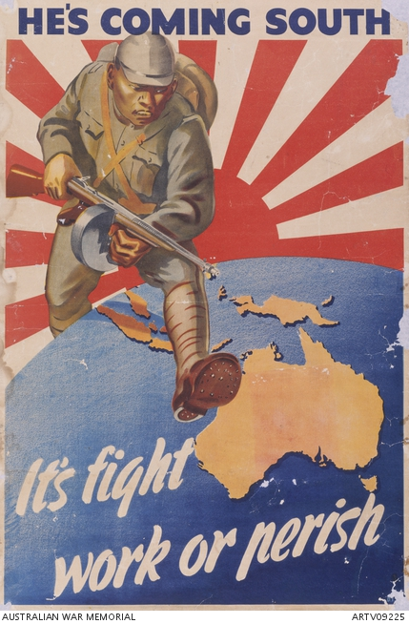

**Source 4:** A map of World War Two in Europe, 1941-1945, created circa 2017.

